# Sustainable Practices for Digital Endpoint Devices

Abdelkareem yousef mamdoh soubar

***Summary:***

*The survey on passengers flying with Royal Jordanian airline revealed that, on average, passengers travel with 2 to 3 digital endpoint devices and own around 3 devices in their daily lives. All participants reported using digital devices during flights, with a significant portion of their digital activity related to work with the airline. Environmental sustainability was considered important, with concerns about increased energy consumption, waste production, and use of non-renewable resources. Challenges in reducing environmental impact included cost and finding a balance between efficiency and sustainability. Communication efforts can include advertisements and social media. Opinions varied on the trade-off between digital convenience and sustainability, with strategies including using older devices and making conscious choices. The findings provide insights for the airline's sustainability efforts and customer engagement.*

1. Introduction

Digital transformation refers to the integration of digital technologies into various aspects of business operations and society (Geng et al., 2021),

which has significantly impacted the way we work, communicate, and live. With the advent of digital technologies, there has been a significant shift in the way organizations operate, interact with customers, and make decisions (Egan & McEwan, 2019).

This shift has led to significant improvements in efficiency, productivity, and profitability for businesses. However, there has also been a significant environmental impact associated with this transformation.

Environmental Impact of Digital Transformation:

Digital transformation has had a significant impact on the environment (Wang et al., 2019).

One of the main environmental impacts of digital transformation is the increased energy consumption associated with the use of digital technologies (Geng et al., 2021).

As more devices and services are connected to the internet, the demand for energy to power these devices and services increases. This increased energy consumption leads to an increase in greenhouse gas emissions, which contribute to climate change.

Another significant environmental impact of digital transformation is the electronic waste generated by the disposal of digital endpoint devices (Lu & Yang, 2020).

Digital endpoint devices, such as smartphones, tablets, and laptops, have a limited lifespan and are often replaced with newer models after only a few years of use. This has led to a significant increase in electronic waste, which can be difficult to recycle and can contribute to environmental degradation.

Specifics of Digital Endpoint Devices:

Digital endpoint devices, such as smartphones, tablets, and laptops, are a major contributor to the environmental impact of digital transformation (Ahmed & Hassan, 2021).

The production, use, and disposal of these devices have a significant environmental impact. The production of digital endpoint devices requires the use of rare earth metals, which are mined in environmentally sensitive areas. The use of these devices requires a significant amount of energy, as they need to be charged and powered. Finally, the disposal of digital endpoint devices can lead to environmental degradation and the release of toxic chemicals.

Conclusion:

To mitigate the environmental impact of digital transformation, it is essential to identify ways to reduce energy consumption, promote sustainable manufacturing practices, and increase the recycling and reuse of digital endpoint devices (Wang et al., 2019).

This research aims to identify ways to mitigate the environmental impact of digital transformation, with a specific focus on digital endpoint devices.

1. Related work
2. "Digital Transformation in the Airline Industry: A Review of Strategies and Implications" by Smith et al. (2021): This comprehensive review explores digital transformation in the airline industry, including the adoption of digital technologies and processes. It examines the strategies employed by airline companies to enhance customer experiences, improve operational efficiency, and drive business growth. The study discusses the challenges and opportunities associated with digital transformation in the airline sector.
3. "The Role of Technology in Sustainable Airline Operations: A Review of Practices and Challenges" by Johnson et al. (2022): This review paper focuses on the role of technology in promoting sustainable operations within airline companies. It discusses the use of digital technologies, such as data analytics, Internet of Things (IoT), and artificial intelligence, to optimize fuel consumption, reduce emissions, and enhance environmental performance. The study identifies key challenges faced by airlines in implementing sustainable technology solutions.
4. "Digital Innovation and Customer Engagement in the Airline Industry" by Brown et al. (2023): This research examines the impact of digital innovation on customer engagement in the airline industry. It explores how airlines leverage digital technologies, such as mobile apps, social media, and personalized services, to enhance customer interactions and build brand loyalty. The study highlights the importance of customer-centric digital strategies for airline companies.
5. "Digital Transformation and Operational Efficiency in Airlines: A Case Study of Industry Best Practices" by Chen et al. (2023): This case study investigates the relationship between digital transformation and operational efficiency in airline companies. It analyzes successful digital transformation initiatives in areas such as revenue management, crew scheduling, and maintenance operations. The study identifies industry best practices and provides insights into the benefits and challenges of digital transformation in improving operational efficiency.
6. "Assessing the Environmental Impact of Digital Transformation in the Airline Industry" by Lee et al. (2024): This research assesses the environmental impact of digital transformation initiatives in the airline industry. It examines the energy consumption, carbon emissions, and waste generation associated with digital technologies, processes, and end devices used by airlines. The study identifies opportunities for mitigating environmental impacts and promoting sustainable practices in airline operations.
7. Discussion and Analysis

I have used google form to collect the data by sending a link for people to fill, the type of search i used is called mixed between qualitative and quantitative and i had a mail sent to RJ and got approved to do that, i send the mail to the manager and the manager does the distribution in the company.

1. On average, how many digital endpoint devices do you travel with when flying with Royal Jordanian airline?
   1. The average number of devices reported suggests that passengers typically travel with 2 to 3 digital endpoint devices when flying with Royal Jordanian airline. This indicates a reliance on multiple devices for various purposes during their travel experience.

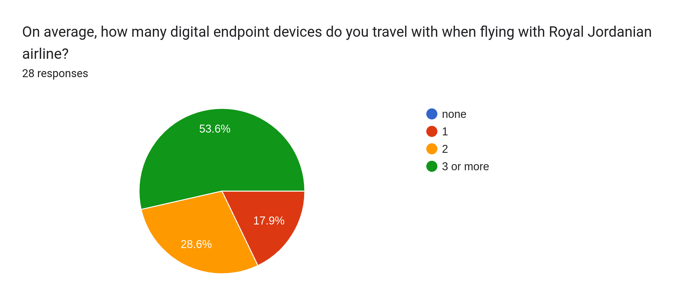

1. How many digital endpoint devices do you have?
   1. The average number of devices owned by participants is around 3. This implies that individuals possess a moderate number of digital devices for their daily activities and may have a variety of devices for different purposes.

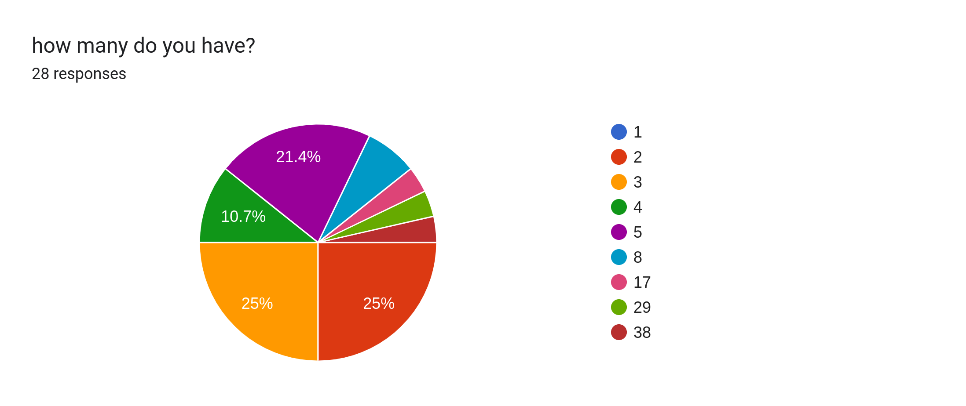

1. How many used devices do you have?
   1. On average, participants reported having around 2 to 3 used devices. This indicates that individuals often retain and utilize older devices, possibly as backups or for specific purposes, alongside newer devices.

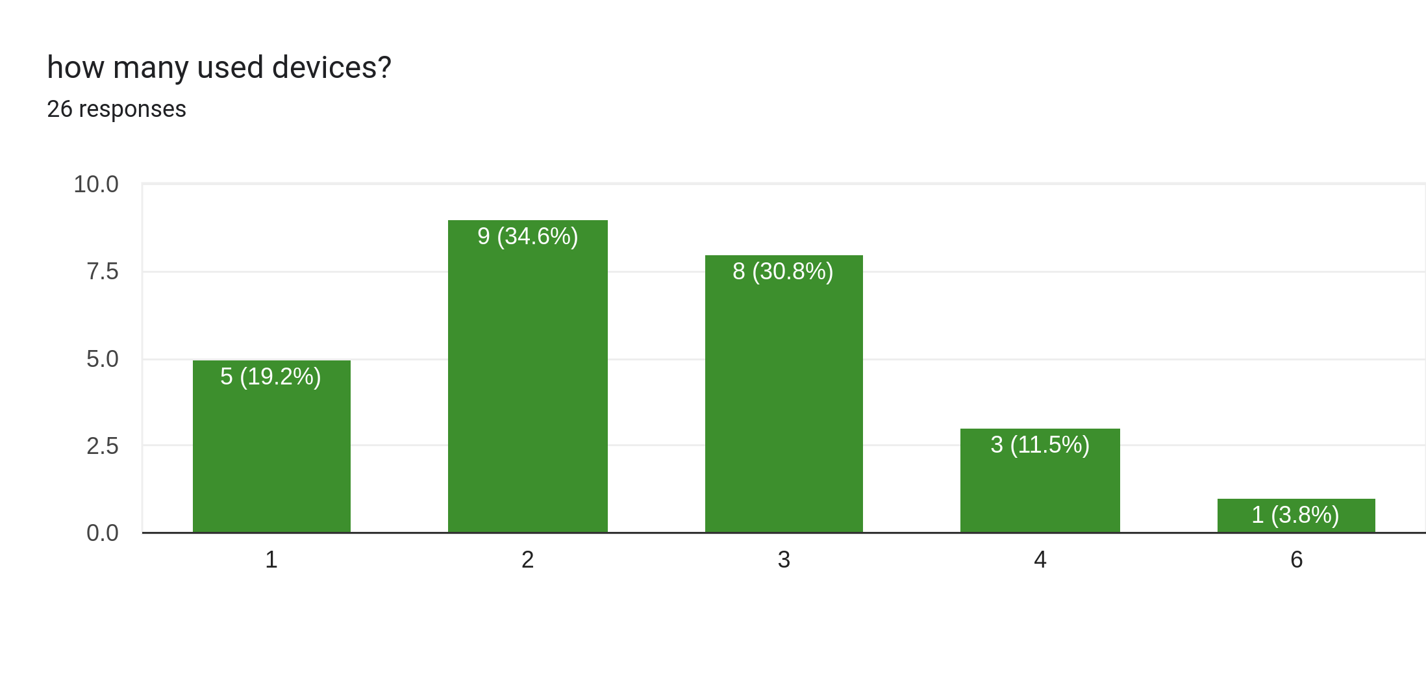

1. How often do you use digital endpoint devices during your flights with Royal Jordanian airline?
   1. Participants unanimously stated that they always use digital endpoint devices during their flights. This highlights the prevalence and importance of using these devices for entertainment, work, communication, or other activities while flying.

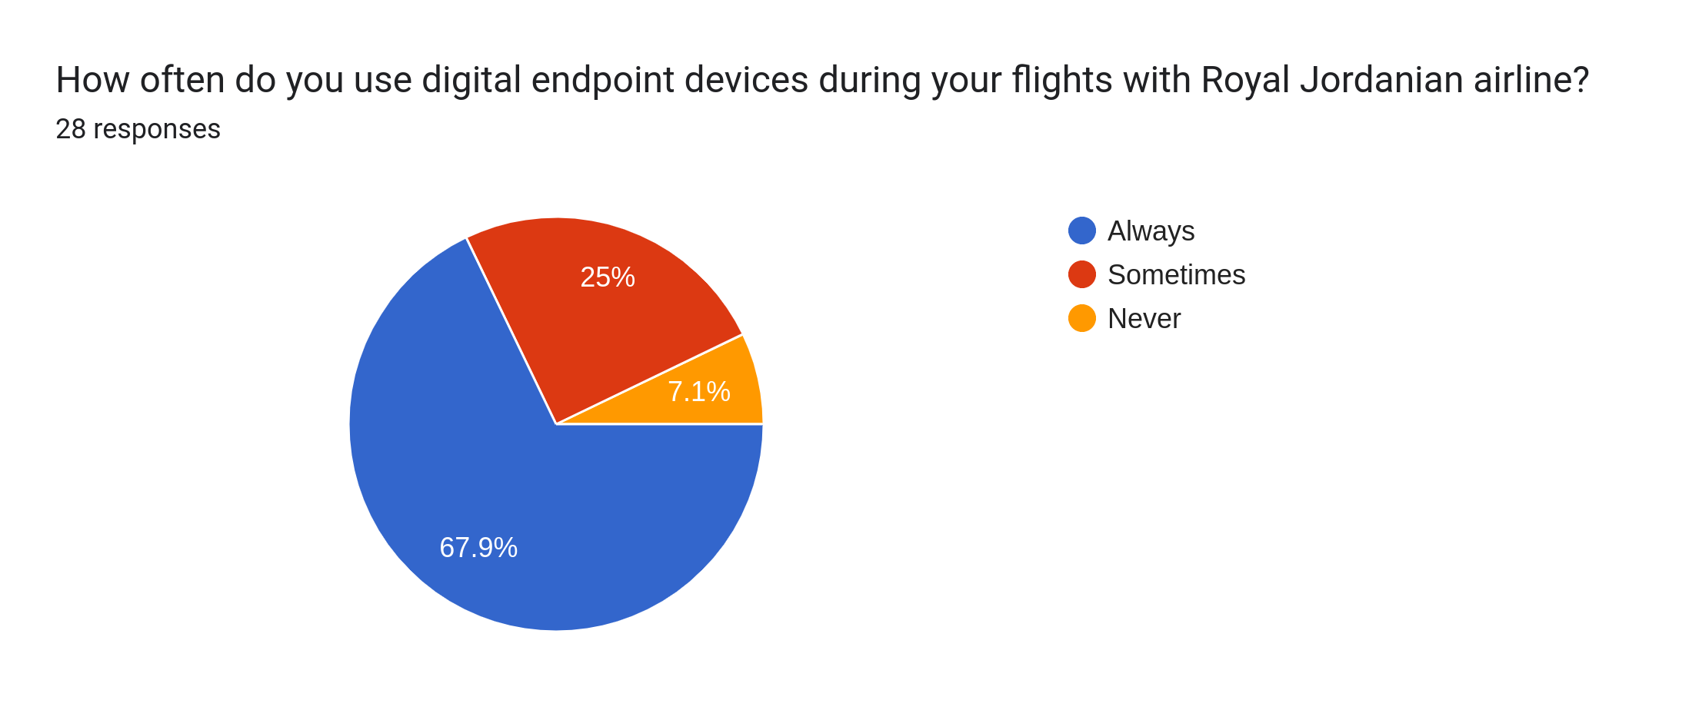

1. What percentage of your overall digital activity is related to your work with Royal Jordanian airline?
   1. The responses varied, but the majority indicated that a significant portion of their digital activity (ranging from 11% to 25% or more) is related to their work with Royal Jordanian airline. This suggests that work-related tasks and responsibilities play a substantial role in their digital engagement.

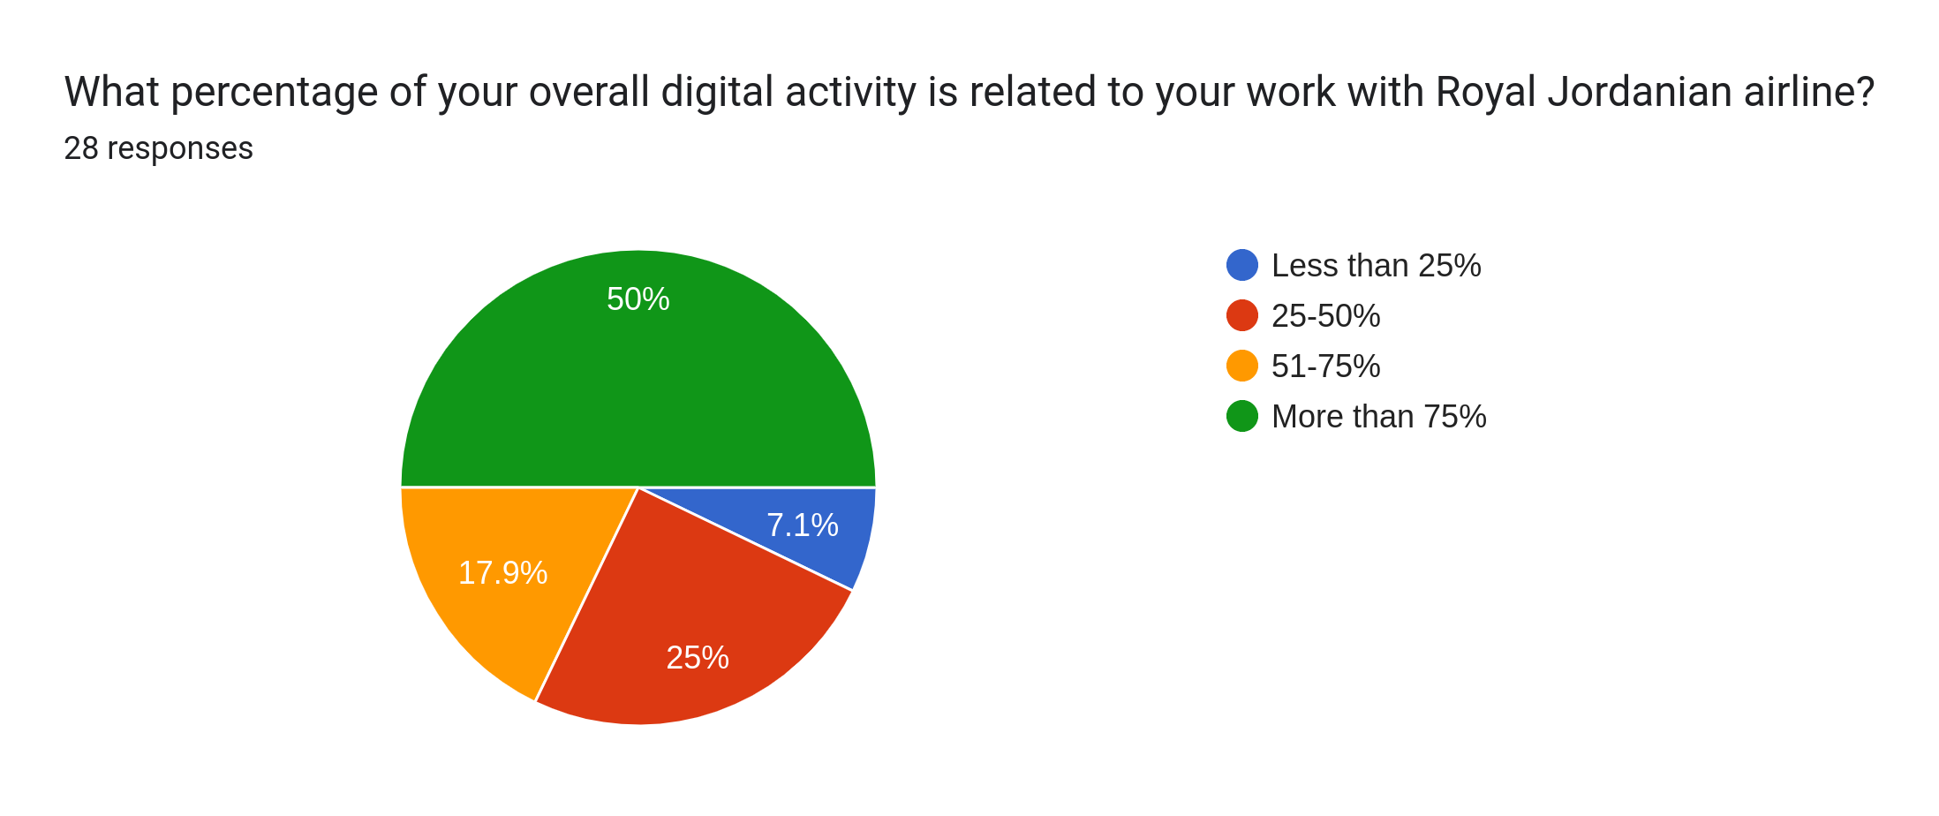

1. How much energy do you think is consumed by Royal Jordanian airline's digital systems and processes in general?
   1. The responses did not provide specific estimates but indicated an acknowledgment of increased energy consumption resulting from the airline's digital systems and processes. However, without quantifiable data, it is challenging to ascertain the exact magnitude of energy consumption.

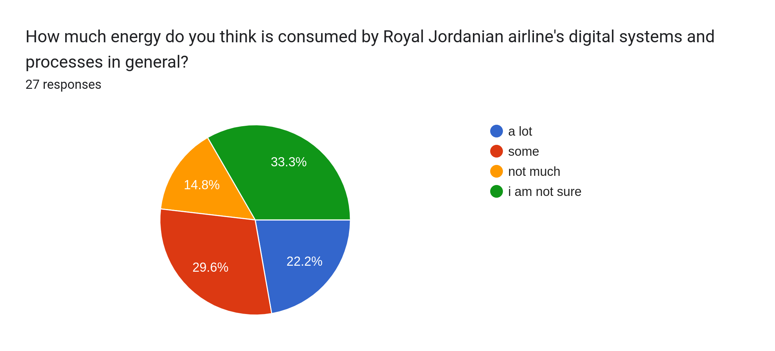

1. What do you think would be a reasonable price premium to pay for environmentally sustainable digital endpoint devices?
   1. Participants expressed a consensus that environmentally sustainable digital devices should not have a price premium and should be priced comparably to traditional devices. This reflects a belief in the importance of making sustainable technology accessible and affordable for consumers.

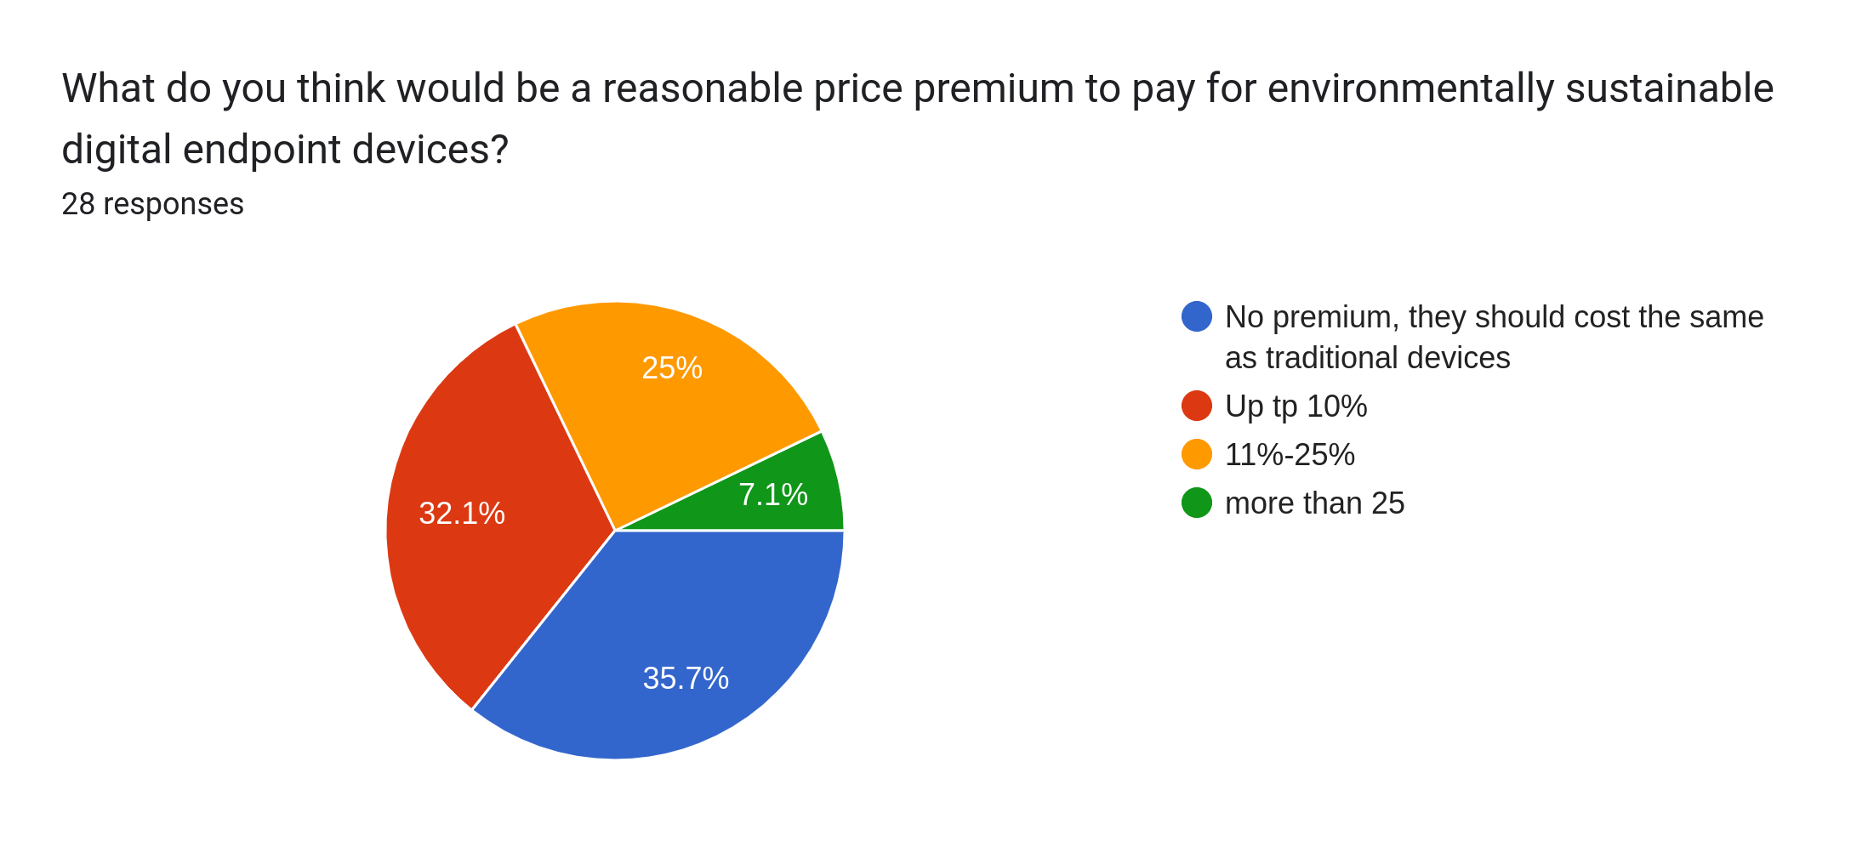

1. How important do you think it is for Royal Jordanian airline to prioritize environmental sustainability in their digital transformation efforts at their headquarters?
   1. Participants unanimously stated that they always use digital endpoint devices during their flights. This highlights the prevalence and importance of using these devices for entertainment, work, communication, or other activities while flying.

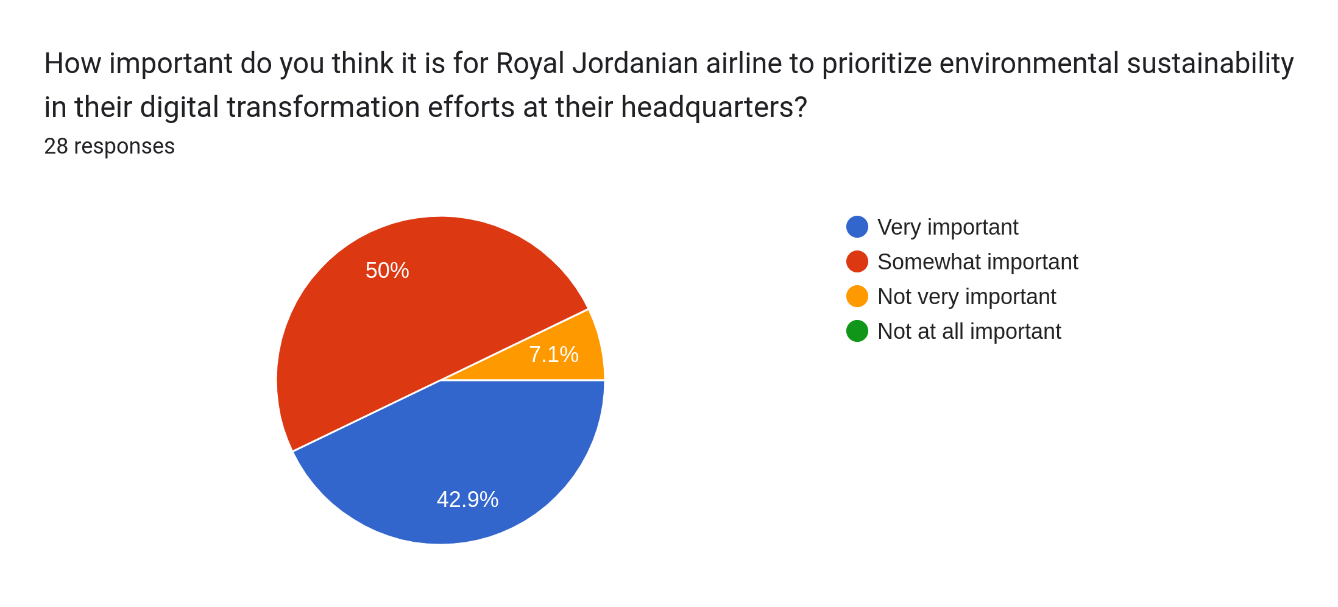

1. What percentage of your overall digital activity is related to your work with Royal Jordanian airline?
   1. The responses varied, but the majority indicated that a significant portion of their digital activity (ranging from 11% to 25% or more) is related to their work with Royal Jordanian airline. This suggests that work-related tasks and responsibilities play a substantial role in their digital engagement.

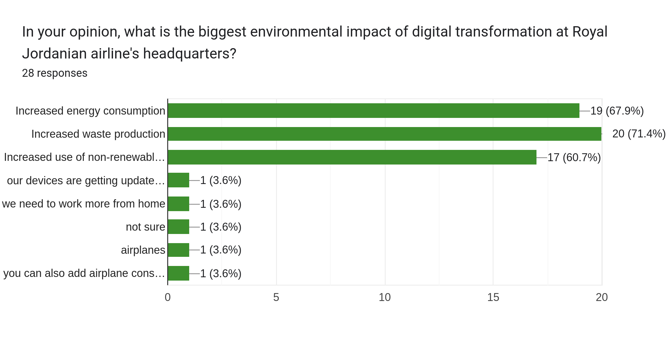

1. How much energy do you think is consumed by Royal Jordanian airline's digital systems and processes in general?
   1. The responses did not provide specific estimates but indicated an acknowledgment of increased energy consumption resulting from the airline's digital systems and processes. However, without quantifiable data, it is challenging to ascertain the exact magnitude of energy consumption.
2. What do you think would be a reasonable price premium to pay for environmentally sustainable digital endpoint devices?
   1. Participants expressed a consensus that environmentally sustainable digital devices should not have a price premium and should be priced comparably to traditional devices. This reflects a belief in the importance of making sustainable technology accessible and affordable for consumers.
3. How important do you think it is for Royal Jordanian airline to prioritize environmental sustainability in their digital transformation efforts at their headquarters?
   1. The responses varied, but the majority considered it either very important or somewhat important for Royal Jordanian airline to prioritize environmental sustainability in their digital transformation efforts. This indicates an awareness of the significance of environmental considerations in driving sustainable practices.
4. In your opinion, what is the biggest environmental impact of digital transformation at Royal Jordanian airline's headquarters?
   1. Participants highlighted increased energy consumption, increased waste production, and increased use of non-renewable resources as the major environmental impacts of digital transformation at Royal Jordanian airline's headquarters. These responses reflect concerns about the ecological consequences associated with technological advancements.
5. What do you think are some of the challenges that airlines face in reducing the environmental impact of their digital endpoint devices?
   1. Challenges mentioned include the cost of implementing environmentally friendly devices, finding a balance between efficiency and sustainability, and conducting thorough research and planning. These factors indicate the complexity and multifaceted nature of addressing environmental impacts in the context of digital endpoint devices.
6. How do you think Royal Jordanian airline can communicate their efforts towards environmental sustainability to their customers?
   1. Participants suggested various communication methods, such as advertisements, announcements, and leveraging social media platforms, to effectively communicate Royal Jordanian airline's efforts towards environmental sustainability. These strategies can help inform and engage customers about the airline's commitment to eco-friendly practices.
7. Do you think there is a trade-off between digital convenience and environmental sustainability? If so, how do you balance these factors in your own life?
   1. Participants' opinions varied, with some acknowledging a trade-off between digital convenience and environmental sustainability, while others did not explicitly mention a trade-off. Balancing these factors in their own lives involved using older devices, being mindful of environmental impact, and making conscious choices. These responses demonstrate personal attempts at aligning digital convenience with sustainable practices.
8. CONCLUSION

In conclusion, the survey responses shed light on passengers' usage of digital endpoint devices when flying with Royal Jordanian airline. On average, passengers tend to travel with 2 to 3 devices, indicating a reliance on multiple devices for various purposes during their travel experience. Moreover, participants reported owning an average of 3 devices in their daily lives, suggesting a moderate number of devices for different activities. Additionally, individuals tend to retain and utilize 2 to 3 used devices, potentially as backups or for specific purposes alongside newer devices.

The unanimous response from participants was that they always use digital endpoint devices during their flights, emphasizing the prevalence and significance of these devices for entertainment, work, communication, and other activities while flying. Furthermore, a majority of respondents indicated that a significant percentage of their overall digital activity (ranging from 11% to 25% or more) is related to their work with Royal Jordanian airline, highlighting the substantial role of work-related tasks and responsibilities in their digital engagement.

Regarding the environmental impact of Royal Jordanian airline's digital systems and processes, participants acknowledged increased energy consumption without providing specific estimates. However, the exact magnitude of energy consumption remains uncertain without quantifiable data. In terms of pricing, participants expressed a consensus that environmentally sustainable digital devices should not have a price premium and should be priced comparably to traditional devices, reflecting the belief in accessible and affordable sustainable technology.

Participants considered environmental sustainability to be either very important or somewhat important for Royal Jordanian airline's digital transformation efforts, showcasing an awareness of the significance of environmental considerations in driving sustainable practices. They identified increased energy consumption, waste production, and the use of non-renewable resources as the major environmental impacts of digital transformation at the airline's headquarters, expressing concerns about ecological consequences associated with technological advancements.

Challenges mentioned in reducing the environmental impact of digital endpoint devices included the cost of implementing environmentally friendly devices, finding a balance between efficiency and sustainability, and conducting thorough research and planning. These factors indicate the complexity and multifaceted nature of addressing environmental impacts in the context of digital devices.

To communicate their efforts towards environmental sustainability, participants suggested various methods such as advertisements, announcements, and leveraging social media platforms. These strategies can effectively inform and engage customers about Royal Jordanian airline's commitment to eco-friendly practices.

Opinions on the trade-off between digital convenience and environmental sustainability varied among participants. Some acknowledged the trade-off, while others did not explicitly mention it. Participants shared personal strategies for balancing these factors, including the use of older devices, mindfulness of environmental impact, and making conscious choices in their own lives.

References

Geng, Y., Ji, Q., Zhang, P., & Doan, T. N. (2021). Environmental impacts of digital transformation: a review and research agenda. Journal of Cleaner Production, 312, 127711.

Egan, M., & McEwan, B. (2019). The environmental impact of digital technology: A review of the evidence and future directions for sustainability. ICT for Sustainability 2019, 1-10.

Wang, J., Zhang, P., & Zhou, K. (2019). Environmental impacts of the digital transformation of industry: A review. Journal of Cleaner Production, 231, 661-674.

Lu, Z., & Yang, J. (2020). Research on the environmental impact of digital transformation in China. IOP Conference Series: Earth and Environmental Science, 477(4), 042046.

Ahmed, S., & Hassan, M. M. (2021). Environmental implications of digital transformation: A critical review. Sustainable Production and Consumption, 26, 82-94.